CSA1717-ARTIFICIAL INTELLIGENCE
PRACTICAL LAB EXPERIMENTS
NIHARIKA PREEJESH (192524506)

PROGRAM 5: BREADTH FIRST SEARCH

Aim:
To implement the Breadth First Search (BFS) algorithm to traverse or search all the nodes of a graph level by level.
Algorithm:
- Start from the source node.
- Mark the source node as visited.
- Insert the source node into a queue.
- While the queue is not empty:
  - Remove the front node from the queue.
  - Visit the node.
  - Check all its adjacent nodes.
  - If an adjacent node is not visited:
    - Mark it as visited.
    - Insert it into the queue.
- Stop when the queue becomes empty.

Flowchart:
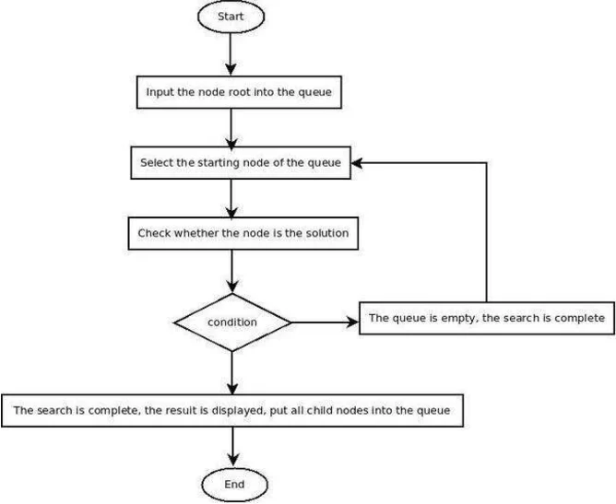

Output:
The nodes of the graph are visited in level-wise order starting from the source node.

Example Output:
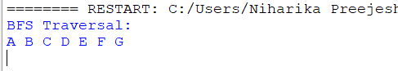

Result:
Thus, the Breadth First Search (BFS) algorithm was implemented successfully, and the graph was traversed level by level.

